**Milestone-1 Documentation**

1. Creating docker containers

* I have dockerised an angular application and pushed it to my docker hub
* Github link of repo : <https://github.com/govindvtra/AngularAppToDeploy>

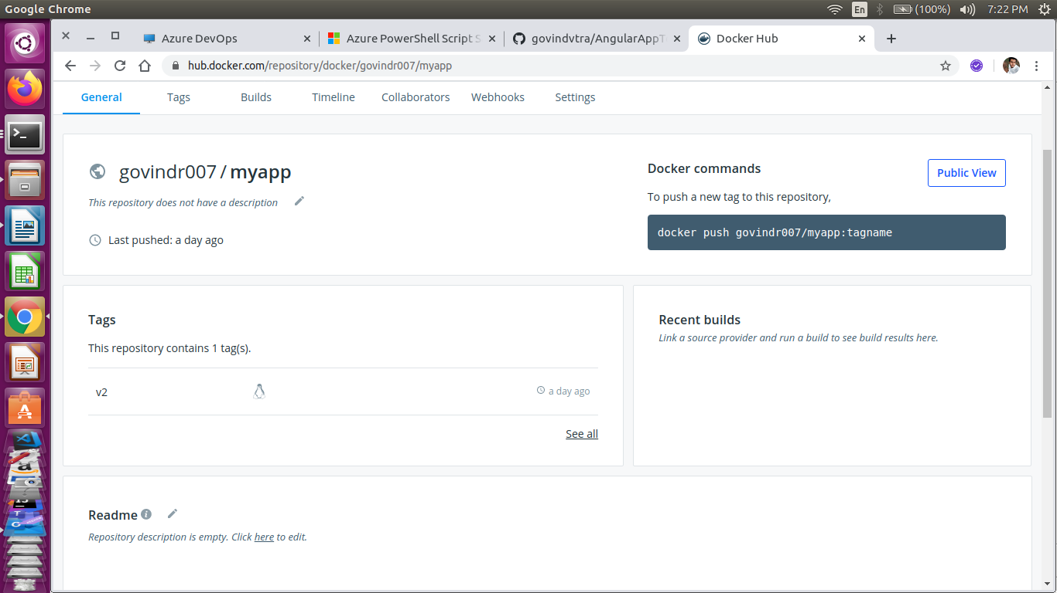

* I have covered all the **basic git commands** during the creation of the repo.
* I have deployed the angular app to **azure app service using azure pipelines**

as well. <https://azureffangular.azurewebsites.net/>

* CI pipeline: <https://github.com/govindvtra/AngularAppToDeploy/blob/master/azure-pipelines.yml>

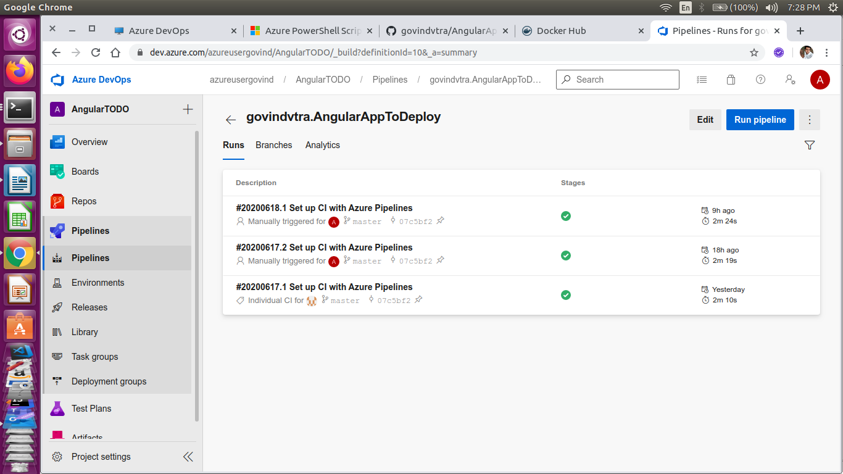

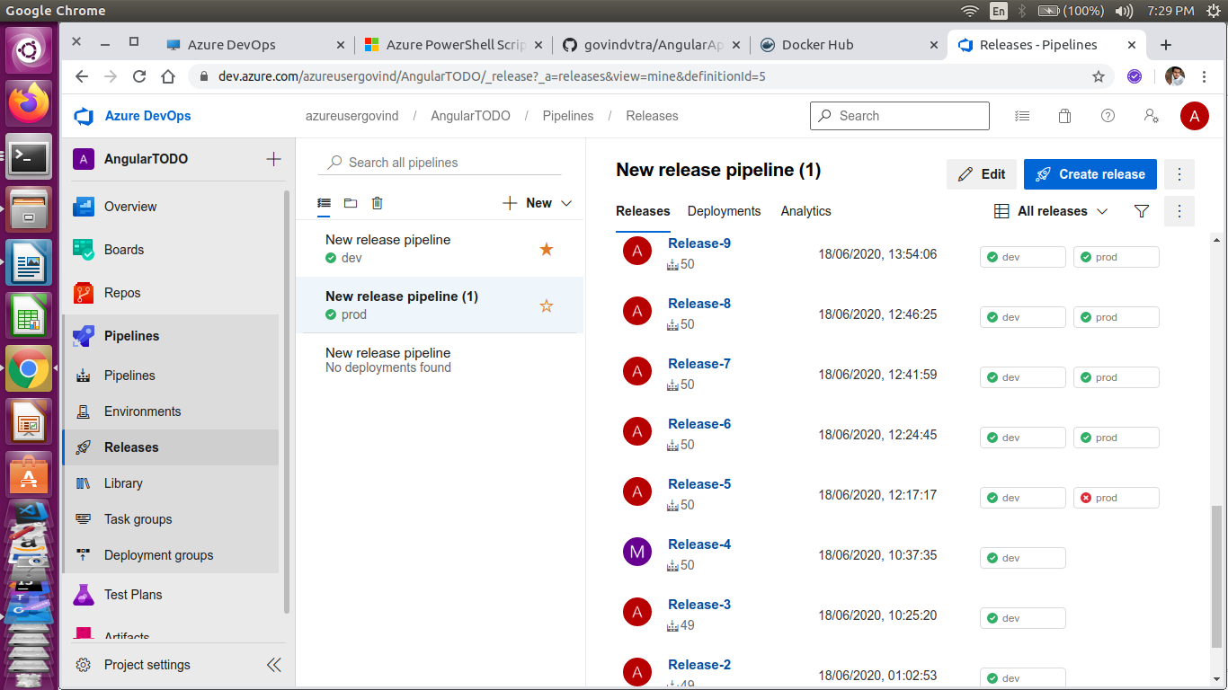

2. Git Commands:

All git commands are used and familiarised in this task.

* git init, add,commit,remote add, push,pull

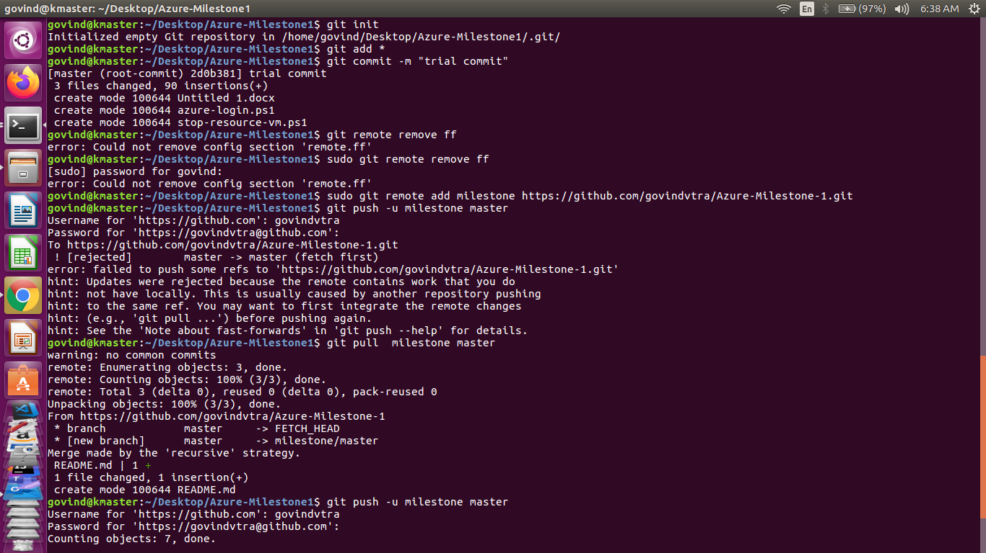

* 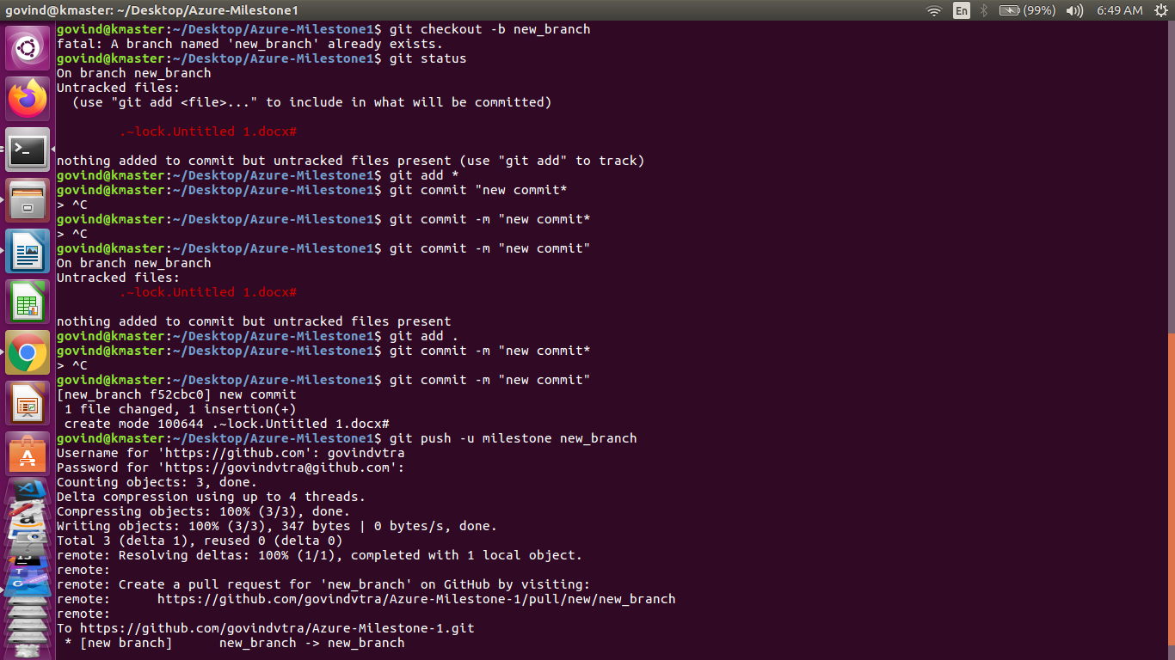git status, checkout

3. Powershell Scripting:

* I have included all my powershell scripts in my repo
* My ps script to create a VM had run successfully

